GREATER PHILADELPHIA SCHUTZHUND CLUB
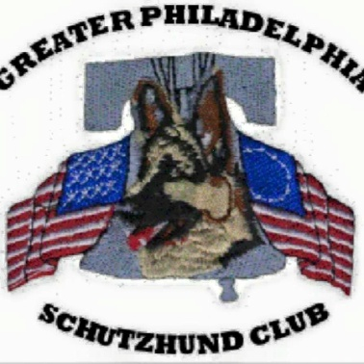
The GPSC will be hosting a Helper Classification &
Northeast Regional Tryout
Saturday July 22, 2023.
USCA Teaching Helper Pedro Jimenez

Location: 47 Ridge Road, Telford, PA 18969 Outdoor training field
Time: 4:00pm – 6:00pm
Contact: Barb RYB44@aol.com
NOTE: Classification & Tryout only – Must have had a prior seminar to register
The purpose of the USCA Helper Program is to educate and develop Helpers that can properly and safely execute the Protection Exercises described in the United Schutzhund Clubs of America Official Rule Book for all Working Dog Evaluations and those required for Breed Surveys and the Sieger Show.
We recommend you review the information and written exam in the USCA Helper Program available on the USCA webpage. USCA Helper Books are required to receive credit for the Classification and tryout for NE Regional Championship Helper.
**Participants should arrange to bring a dog to work during the classification or Regional Tryout evaluation**

Hotels: Holiday Inn Lansdale – 215-368-3800 * Courtyard Marriott (Lansdale) – 215-412-8686 Quality Inn & Suites - 215-538-3000 * Holiday Inn Express -215-529-7979 (Quakertown)

